**ROAD ACCIDENT DASHBOARD**

**REQUIREMENT:**

* **Total Casualties taken place after the accident.**
* **Total Casualties and percentage of total with respect to accident severity and maximum casualties by type of vehicle.**
* **Total Casualties with respect to vehicle type.**
* **Monthly Trend showing comparison of casualties for 2021 and 2022 year.**
* **Maximum casualties by Road Type.**
* **Distribution of total casualties by Road Surface.**
* **Relation between Casualties by Area/Location and by Day/Night.**

**PROCESS INVOLVED:**

* **Data Cleansing**
* **Data Processing**
* **Data Analysis**
* **Data Visualization**
* **Dashboard Building**

**SCREENSHOT OF THE DASHBOARD:**

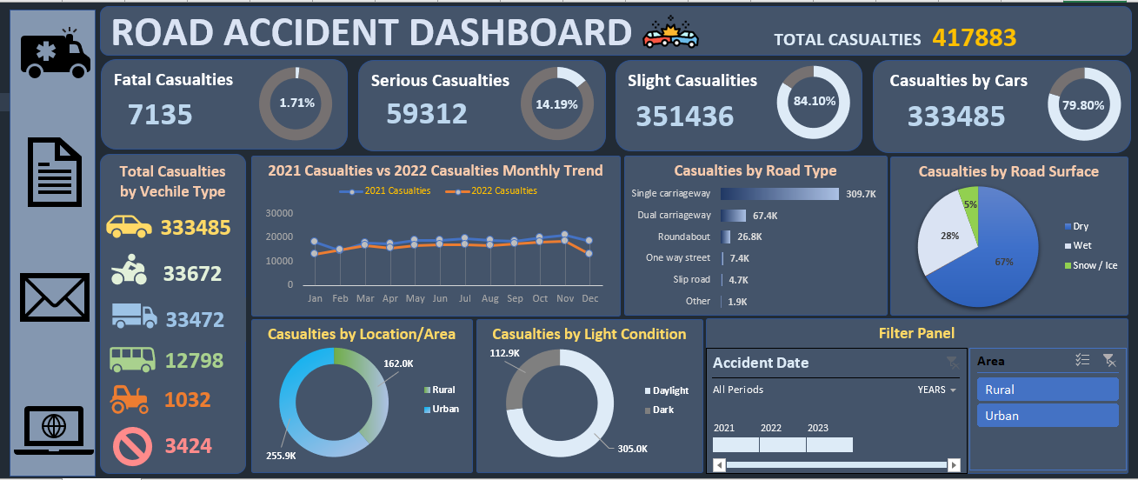

**Link : <https://docs.google.com/spreadsheets/d/1cuIbK4ne44VGhdOx4YqM377d1JNiVFTi/edit?usp=sharing&ouid=104959745992124424701&rtpof=true&sd=true>**